PSHE Sex Ed

FYI, Mother’s Choice offers a series of three workshops for each year group from F.1 (Grade 7) to F.4 (Grade 10), to be conducted in a sequential manner. Each workshop is 60 minutes, for 40 students only. We may try to develop two sessions for each year group by referring to the Mother’s Choice curriculum table below.

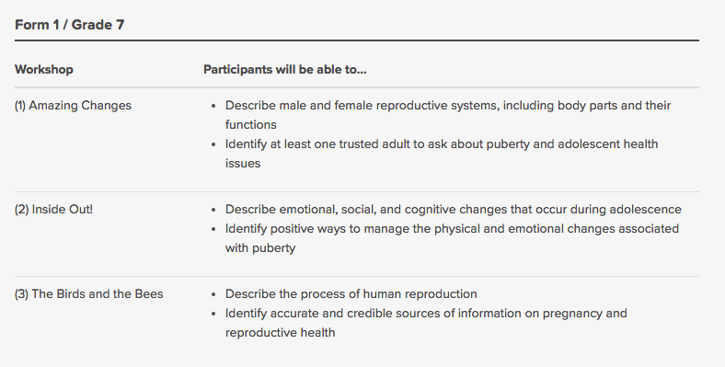

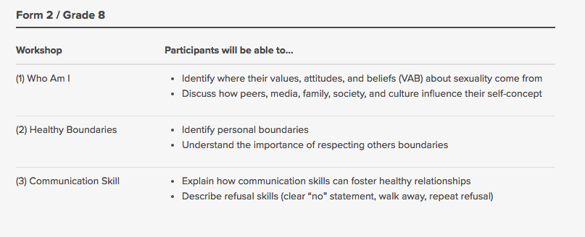
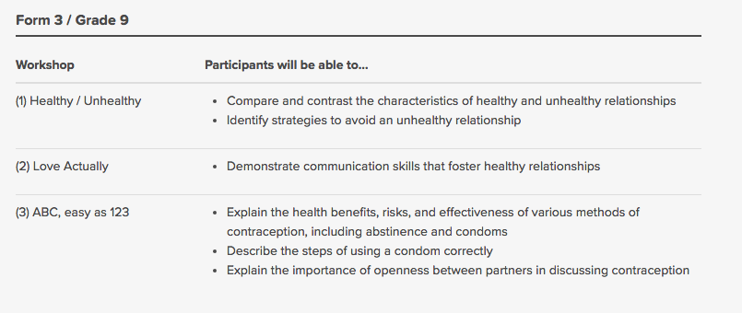

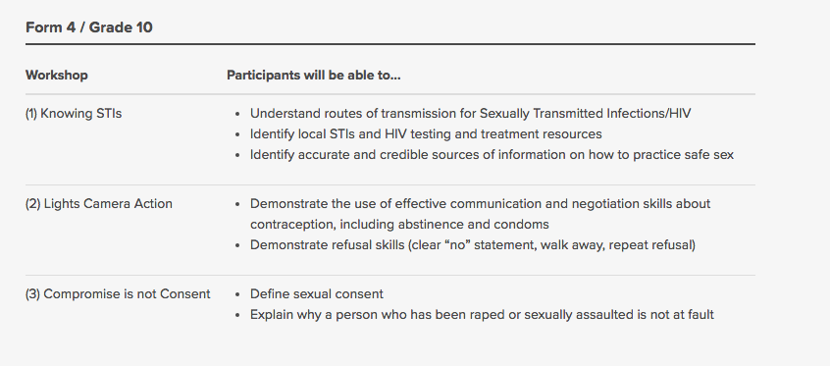

In general: ages 11-14, students learn about sexual activity, human reproduction, contraception, pregnancy, sexually transmitted infections, relationships, and ages 14-16, students learn about body image and health, choices about sex, parenting skills and family life, separation and divorce. Please also cover topics related to sexual orientation and sexual harassment.

Maybe teachers will find this helpful:

Family Planning Association of Hong Kong
Sexuality education program:
https://www.famplan.org.hk/en/events-and-programs/sexuality-education-programs/detail/OP

https://www.studenthealth.gov.hk/english/newsletters/files/bridge65.pdf

Mother’s Choice:
https://www.motherschoice.org/en/what-we-do/for-youth/book-a-sexuality-education-workshop/

https://www.studenthealth.gov.hk/english/health/health_se/health_se.html

http://www.thestandard.com.hk/section-news.php?id=201117&sid=4

